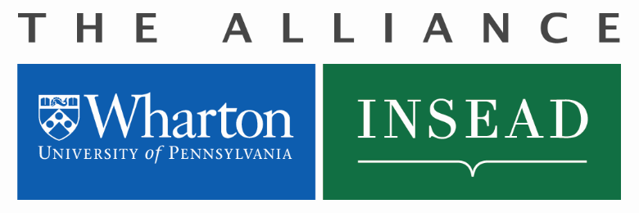
Wharton-INSEAD Center
for Global Research and Education
Short Term Visit Request
Definition of a Short Term Visit

Designed to encourage exploratory visits to host school in order to establish research contacts with a view towards enhancing collaborative research project, teaching innovations, attend PhD defense dissertation. Duration of up to four (4) weeks.
Short Term Visits can also be used to attend co-branded conferences, lectures or seminars up to three (3) nights as a guest speaker.
Application Process

- Faculty/Staff Member completes the Application below and forwards to:
Guillaume Roels, Research Director, INSEAD-Wharton Alliance, guillaume.roels@insead.edu ,
Michele Anna Klekotka, Administrative Manager, Wharton INSEAD Alliance, klekotka@wharton.upenn.edu; Suzanne Sellier Di Sano, suzannesellierdisano@insead.edu
- If approved, Guillaume Roels will sign the Application and Michele Anna Klekotka will provide the approved Budget amount and Project Number.
Application for Short Term Visit
Name: Email Address:
Date of proposed visit (From/To): mm/dd/yyyy Department Name:
Home School (Wharton or INSEAD): mm/dd/yyyy Faculty, Ph.D. Student, or Staff:
Nature of the STV:
Investigate Possible Collaborative Research Project
Attend PhD Defense Dissertation for Student Involved In Collaborative Research Project
Teaching Innovations
Other (specify) _________________________
Conference/Lecture/Seminar. Only co-branded events held at INSEAD or Wharton will be covered (air travel, ground transportation to and from airports, accommodation up to 3 nights). Faculty must be an invited speaker to an advertised co-branded event held at host school.
Date and Title of Conference/Seminar:
Faculty Sponsor/Host School Department

Budget Request

All budgets will be awarded in Euros and will be adjusted to reflect the Exchange Rate at the date of the expense.

Reimbursements will be paid upon submission of original receipts only. Double-click on the Excel table below to enter your budget request. Formula will calculate the conversion from USD to Euros as necessary.

Short Term Visits:
- Funding up to four (4) weeks pending Alliance approvals.
- One round trip Economy air ticket to host school;
- Ground transportation to and from airports (Philadelphia and INSEAD)
- Accommodation for up to (4) weeks at INSEAD Residence or other location arranged by host school/department for up to a maximum of 2,500 Euros including taxes per visit.
- Visa, if required
- No Per Diem
- Original itemized receipts required.

Colloquia - Conference/Lecture/Seminars:
- The Alliance will cover up to (2) co-branded conference/research seminars per department annually for faculty who are invited as a guest speaker.
- Funding up to three (3) nights pending Alliance approvals for:
  - Guest speaker at a co-branded conference/seminar at partner school for up to (4) days;
  - Accommodations may be arranged by host department. Lodging covered up to (3) nights to a maximum of 225.00 /Euros per night, including taxes.
  - Ground travel (taxi) to and from the airport;
  - No Per Diem
  - One (1) roundtrip Economy air ticket to host school;

To be completed by Michele Anna Klekotka, Alliance Manager
Date of Approval: Amount Approved €: Wharton-INSEAD Project #:

