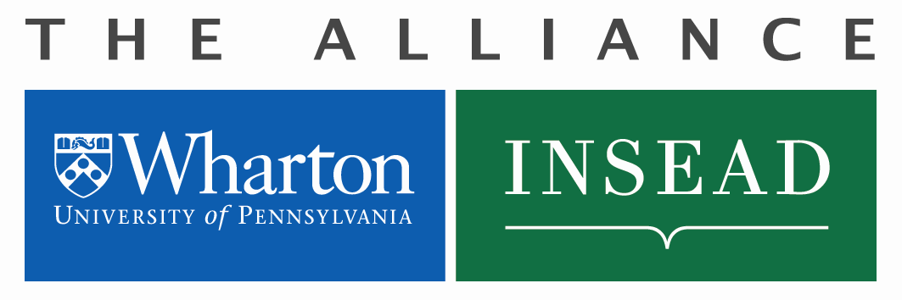

Faculty Exchange Request

Definition of a Faculty Exchange

A faculty member from either Wharton or INSEAD becomes a faculty member on the partner school’s campus to participate in the academic life in research and/or teaching in the host institution’s courses. The Exchange is an institutional arrangement that operates on the basis of reciprocity.

The Exchange may be full-time (one academic year), or partial. In case of partial exchange, the residence period is proportional to the extent of the exchange. For example, for a 1/3 exchange, the residency period on the host institution’s campus will be 3 months, i.e., 1/3 of 9 months.

Application Process for Wharton Faculty

- Interested Faculty Member should obtain a verbal commitment from their collaborator at host school
- Department Chairperson forwards to the Deputy Dean for signature
- Deputy Dean forwards to Executive Director Tom Robertson for signature
- Executive Director forward to Alliance Manager Michele Anna Klekotka who will obtain INSEAD signatures
- After all signatures are obtained, Faculty Member will receive an Invitation Letter from the host department listing details of their arrangement (dates of stay, financial funding provided by host department, etc.)
- Once the Invitation Letter is received, you may request additional funding using the “Faculty Exchange Funding Request” found on the Alliance website.

Application for Faculty Exchange

Name : Date: | Email Address:
Period of Exchange (From/To): mm/dd/yyyy | Host School Department Name:
Home School (Wharton or INSEAD): | Home School Department Name:
Course(s) to be taught at partner school (If no teaching is involved, please enter N/A):

Course title: Period: | INSEAD Teaching Units:
Course title: Period: | INSEAD Teaching Units:
Course title: Period: | INSEAD Teaching Units:

Approval Signatures

Faculty Member | Date:
Department Chairperson | Date:
Wharton Deputy Dean | Date:
INSEAD Area Coordinator | Date:
INSEAD Dean of Faculty | Date:
Alliance Executive Director: | Date:

To be completed by Michele Anna Klekotka, Alliance Manager

Date of Approval: Amount Approved €: Wharton-INSEAD Project #:

