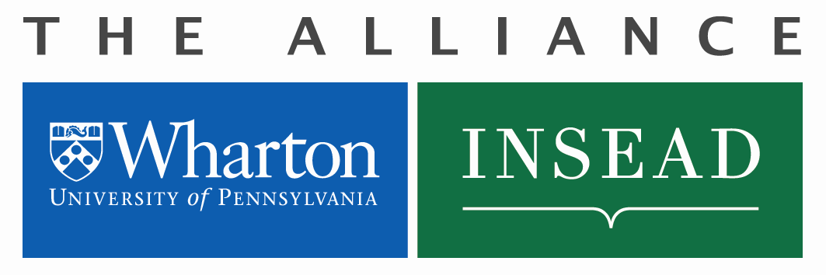
Wharton-INSEAD Center
for Global Research and Education
Doctoral Student
Short Term Visit (STV) Request

Definition of a Doctoral Student STV

Designed in part to allow doctoral students to visit the partner school to conduct research under the guidance of a faculty sponsor at the partner school. The duration of an STV for doctoral research can be up to four (4) weeks.
STVs can also be used to attend co-branded (Wharton and INSEAD) conferences or workshops. Attendance for these events can be up to three (3) nights and must be relevant to the student’s research. Doctoral STVs cannot be used for the annual PhD Student Consortium, which is funded separately by the Alliance.
The Alliance will grant a total of two (2) STVs per academic year, per school. Students are permitted to participate in one approved STV during their doctoral studies. First year students are not eligible.

4-Week Visit: Effective 1 September 2019, applications for STVs of maximum 4-week duration must be submitted by 31 May of the calendar year.
Colloquia: Students wanting to travel to host school for a STV colloquia after 1 September 2019 must apply before 31 May 2019. Effective 1 September 2019, STVs relevant to colloquia will require minimum notice of two (2) months prior to departure date.

Financing for all PhD student exchanges are open to doctoral students only.

Application Process

- Doctoral student receives an (email) invitation from a faculty sponsor at the partner school to conduct research under their guidance, or attend a co-branded conference or workshop relevant to the student’s research.
- Doctoral student receives approval from their PhD Advisor and PhD Department Coordinator.

- Student completes the Application below and forwards it along with the partner school’s (email) invitation to:
Guillaume Roels, Research Director, INSEAD-Wharton Alliance, guillaume.roels@insead.edu
Michele Anna Klekotka, Administrative Manager, INSEAD-Wharton Alliance, klekotka@wharton.upenn.edu
Suzanne Sellier Di Sano, Manager, INSEAD-Wharton Alliance, suzanne.sellierdisano@insead.edu

- Should your application be approved, Michele Anna Klekotka will send you an award letter with approved budget figure and corresponding budget number to be used for reimbursements. Original receipts are required for reimbursement.
- If using the STV for research, the student will submit a 500-word summary outlining results.
Application for Doctoral Student STV
Name: Email Address:
Date of proposed visit (To/From): mm/dd/yyyy Student’s Department Name:
mm/dd/yyyy Faculty Sponsor from Partner School:
Student’s Home School (Wharton or INSEAD): Name of student’s PhD Advisor
Nature of the STV:
Research under the guidance of Faculty Sponsor Professor (named above);
Conference or Workshop. Only co-branded events relevant to your research and held at Wharton or INSEAD will be covered (air travel, ground transportation to/from airports, accommodation up to 3 nights).
Title of Conference/Workshop:
Provide an explanation for why you are requesting an STV for your research:

If attending a co-branded conference or workshop, please provide the title of the event and how it is relevant to your doctoral studies:

Approval signature of PhD Advisor: _____________________________________________
Approval signature of PhD Department Coordinator: _____________________________________________
Faculty Sponsor signature: _____________________________________________
Approval signature PhD Vice-Dean/Academic Director: _____________________________________________

Budget Request

All budgets will be awarded in Euros and will be adjusted to reflect the Exchange Rate at the date of the expense.
Reimbursements will be paid upon submission of original receipts only. Double-click on the Excel table below to enter your budget request. Formula will calculate the conversion from USD to Euros as necessary.
Short Term Visits:
- Funding up to four (4) weeks pending Alliance approvals
- One round trip economy airline ticket to host school with cap of 1,000 Euros for France and 1,600 Euros for Singapore.
- Ground transportation to/from airports (Philadelphia and INSEAD)
- Accommodation for up to (4) weeks and maximum 1000 Euros for Philadelphia and Fontainebleau (or 1,474 Euros for Singapore) including taxes per visit
- No Per Diem
- Original itemized receipts required
Visas must be handled by the student and proof of visa should be provided before departure.
Conferences or Workshops:
- Funding up to three (3) nights pending Alliance approvals for:
- Attendance at a co-branded (Wharton and INSEAD) conference/seminar at partner school for up to (3) nights
- Accommodations should be arranged by host department at partner school. Lodging covered up to (3) nights to a maximum of 200/Euros per night, including taxes
- One round trip economy airline ticket to host school with cap of 1,000 Euros for France and 1,600 Euros for Singapore.
- Ground travel to/from the airport
- No Per Diem
- Original itemized receipts required

To be completed by Michele Anna Klekotka, Alliance Manager
Date of Approval: Amount Approved €: Wharton-INSEAD Project #:

