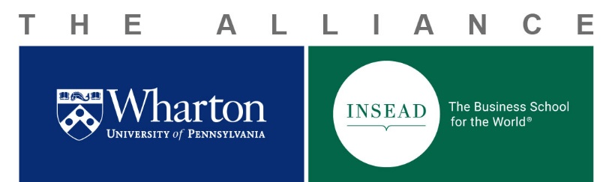

Eighth Wharton-INSEAD Doctoral Consortium 2019 FAQs

Who can apply to participate in the Consortium?
1. Do I have to be in a particular discipline?
No. Students from ALL Wharton and INSEAD doctoral programs are encouraged to apply, if their research proposal is relevant to the common theme of the Consortium in business studies.

2. Am I too early/late in my program to apply?
No. We welcome applications from students at any stage of their program. Our only requirement is that you are in your second year or above of the INSEAD or Wharton doctoral program in the autumn of 2019 (e.g. not graduated or first year).

3. How many students will be accepted to participate?
We do not have a fixed number, but this year we are aiming to accept around 35 students. We will try to ensure that about the same number of students participate from Wharton and from INSEAD; we will also try to ensure a fair split between Fontainebleau and Singapore.

What projects will be considered for the Consortium?
4. Do I have to have a finished paper ready by the date of the Consortium?
No. We expect students to be presenting work in progress. There is no requirement that you have a finished paper ready. Ideally, the Consortium is an opportunity for you to “test out” a project that will be used to fulfill a program requirement (such as a second-year paper, or a piece of your dissertation), that you intend to present at a major conference, or even your job-market paper – but any original work is welcome!

5. What else can you tell me about what you are looking for?
We are looking for any original work that is relevant to management science. You might want to keep in mind the diversity of the Consortium (in terms of disciplines, methods, and research questions) and think about how your project will spark conversations and interest among Consortium participants and faculty attendees. Successful applications will have a clear motivation, research question, and empirical approach. Theoretical papers will also be considered.

6. Should I select the 15-minute or the 30-minute format?
That is really up to you, how far along you think your project will be by the time of the Consortium, and how comfortable you are presenting it.

7. Does the Organizing Committee decide who gets accepted?
No. All applications will be submitted to a double-blind review process. Reviewers will be other applicants (yes, by applying, you are committing to serve as a reviewer) as well as other volunteer reviewers. Reviewer and applicant will never be from the same institution (all Wharton applications will be reviewed by INSEAD reviewers, and vice versa).

How does the application process and funding work?

8. I’ve missed the deadline; can I still apply?
No. The deadline of Friday, May 10th, 2018, at 23:59 EDT will be strictly enforced. If you spilled coffee on your computer just as you were about to press “send” at 23:59 EDT, and you have video evidence, drop us a line.

9. I’ve emailed you my application instead of using the application form in Qualtrics, will my application still be considered?
No. Please use the application form as it provides important information about your proposal that will help match your proposal to appropriate reviewers.

10. What items will I be reimbursed for?
All accepted INSEAD students will be reimbursed funding to cover shared ground transportation to and from Philadelphia International Airport and one economy round-trip flight, in accordance with INSEAD-Wharton Alliance policies. Please note that Fontainebleau-based students will be reimbursed a maximum amount of €700 for their round-trip flights between Paris and Philadelphia, and Singapore-based students will be reimbursed a maximum amount of €1200 for their round-trip flights between Singapore and Philadelphia. To guarantee reimbursement, airfare to Philadelphia should be booked as the student is notified of the review committee decision and no later than June 20th. Accommodation in Philadelphia will also be provided. Food and beverages during the Consortium and social events will be covered for all participants.

What about the rest of the Consortium program?

11. What else happens at the Consortium?
We have plenty of fun surprises in store, but you can expect faculty panels on conducting research and publishing in top-tier journals, informal student break-out sessions, and memorable social events. We look forward to having you there!

12. I still have a question.
In that case, please get in touch with a member of the Organizing Committee from your institute, and we will do our best to answer it!

INSEAD:
Ece Guliz Gulserliler, Rising 2nd year, Technology and Operations Management, eceguliz.gulserliler@insead.edu
Xinwei Li, Rising 2nd year, Finance, xinwei.li@insead.edu

Wharton:
Xiao Betty Wang, Rising 5th year, Applied Economics, xiao3@wharton.upenn.edu
Vladimir Pavlov, Rising 4th year, Marketing, vpavlov@wharton.upenn.edu

