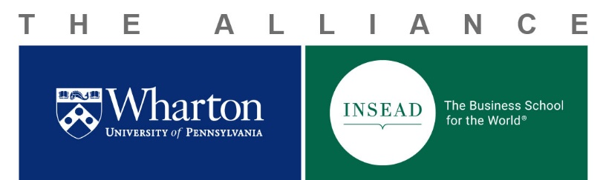
Wharton- INSEAD Doctoral Consortium 2019
CALL FOR APPLICATIONS
We are happy to invite you to the Eighth Wharton- INSEAD Doctoral Consortium, sponsored by the INSEAD-Wharton Alliance. This event will be held on October 25 -27, 2019, at the Wharton School in Philadelphia, U.S.
The Consortium is a forum for doctoral students from Wharton and INSEAD to present their research and foster networks of collaboration across institutions and disciplines. In the spirit of the diversity of our institutions, we invite submissions from ALL Wharton and INSEAD doctoral programs, including Management, Economics, Health Care Economics, Quantitative Marketing, Finance, Accounting, Organization Behavior, Behavioral Marketing, Decision Science, Technology & Operations Management, Strategy, Entrepreneurship, Healthcare Management, Technology, Ethics & Legal Studies, Statistics, etc.
The Consortium will include student presentations, keynote presentations, and panel sessions led by Wharton faculty. The Consortium will also include social events both on the Penn campus and off-site.
Applications must be made electronically (the registration link) no later than May 10th (23:59 EDT) with the following guidelines:
- The application requires an abstract of no more than 200 words, and an overview of no more than 1,000 words (not including references or tables) that describes the research project or paper.
- Given that one of the main goals of the Consortium is to facilitate the combination of resources that help advance academic research, we welcome incomplete research endeavors. All of the work must be original and unpublished.
- The applicant should indicate a preference for one of the two presentation formats:
  - Shared session. A 15-minute plus Q&As presentation that allows the student to introduce the main theoretical elements and research design of a research project.
  - Longer session. A 30-minute plus Q&As presentation that provides students with an opportunity to present more in-depth findings and receive extensive feedback.
- A double-blind review process will be implemented; thus, applicants should NOT identify themselves in any part or in any form of the submitted research.
- Note that all applicants will be REQUIRED to review at least two papers submitted by other applicants from the other institution (e.g., a Wharton applicant reviewing two of INSEAD applicants’ papers).

Timeline:
May 10th, 2019, 23:59 EDT | Submission deadline for applications
May 13th – May 27th | Review time period
May 29th | Notifications of review committee decisions
June 14th | Presenter registration deadline
June 20th | Flight tickets purchase deadline
Oct 25th – 27th, 2019 | Eighth Wharton-INSEAD Doctoral Consortium at the Wharton School, Philadelphia, U.S.
Funding:
All accepted INSEAD-Fontainebleau and INSEAD-Singapore students will be reimbursed funding to cover shared ground transportation to and from Philadelphia International Airport and one economy-fare round-trip flight, in accordance with INSEAD-Wharton Alliance policies. Please note that Fontainebleau-based students will be reimbursed a maximum amount of €700 for their round-trip flights between Paris and Philadelphia, and Singapore-based students will be reimbursed a maximum amount of €1200 for their round-trip flights between Singapore and Philadelphia. Please note that the airfare cap will be strictly enforced. To guarantee reimbursement, the necessary airfare to Philadelphia should be booked as soon as the student is notified of the review committee decision and no later than June 20th. Accommodation in Philadelphia will also be provided. Food and beverages during the Consortium and social events will be covered for all participants.
If you have any questions about the Consortium and the application process, please refer first to the attached FAQs!
We look forward to your applications!
Best Regards,
Organizing Committee:
INSEAD:
Ece Guliz Gulserliler, Rising 2nd year, Technology and Operations Management, eceguliz.gulserliler@insead.edu
Xinwei Li, Rising 2nd year, Finance, xinwei.li@insead.edu
Wharton:
Xiao Betty Wang, Rising 5th year, Applied Economics, xiao3@wharton.upenn.edu
Vladimir Pavlov, Rising 4th year, Marketing, vpavlov@wharton.upenn.edu
--------------------------------------------------------------------------------------------------------------------------------
The Wharton–INSEAD Alliance joins the resources of two world leaders in management education, creating global access to unparalleled business knowledge for students, faculty, and executives worldwide. The partnership extends top-quality business education across five dedicated campuses: Wharton's U.S. campuses in Philadelphia and San Francisco, and INSEAD’s campuses in Fontainebleau, France; Singapore, and Abu Dhabi.
The Alliance advances global business research and practice through exchange programs, a collaborative research center, joint executive education programs, and cross-school alumni events.

