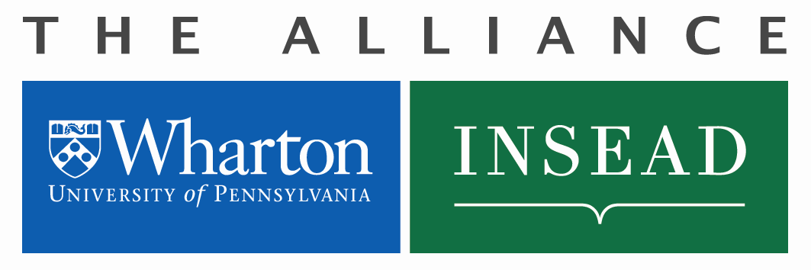
Wharton-INSEAD Center
for Global Research and Education
Ph.D. Exchange
Funding Request

Funding Application Process

- Requests for funding should be made to the Director of the Alliance Research Centre – Gavin Cassar: gavin.cassar@insead.edu and copy to Michele Anna Klekotka: klekotka@wharton.upenn.edu

- Financial support (travel and housing) – once a student receives a letter of invitation from the PhD program office for either school, financial support may be available by submitting this funding request. Support may be awarded after successful completion and approval of both the application and budget, review and acceptance of terms and conditions, and a copy of student visa are sent to Michele Anna Klekotka klekotka@wharton.upenn.edu
Note: All approvals must be obtained two (2) months before the registration date at the host institution.
- Items covered: travel (one return economy class airfare), ground transportation (taxi to and from airport for departure and return trip), and housing/apartment (INSEAD-Fontainebleau residence, Fontainebleau or Philadelphia housing up to €1000 per month, and Singapore is up to €1475 per month).
- Items not covered: books, utilities or technology related purchases (computers, cell phones, etc.), living expenses such as meals, local transportation and telephone charges covered by your stipend.
- Acceptance to the PhD Exchange Program is not a guarantee of receiving funding from the Alliance Research Center.
- All budgets are awarded in Euros and will be strictly adhered to.

- Reimbursements are processed at the home school after submission of original itemized receipts. All original receipts will need to be reviewed and approved by the home school prior to payment by the designated staff person below:

- Wharton Reimbursements: Contact Departmental Business Administrator
- INSEAD Reimbursements: Contact Hélène Goudeau, Department of Faculty & Research: helene.goudeau@insead.edu

- All reimbursements must have an approved project number (2399-xxx) from the Alliance, and submitted with the Request.
- Funding and reimbursements will cease at the end of the visit to the host school, and do not rollover.
Double-click in the following Excel table to enter your budget request. Formula will calculate your total budget, and the conversion from USD to Euros as necessary.

Funding Application

To be completed by Michele Anna Klekotka, Alliance Manager

Date of Approval: Amount Approved €: Wharton-INSEAD Project #:

